**Basic SQL Queries**

1. Retrieve all movies and shows.

select *

From titles;

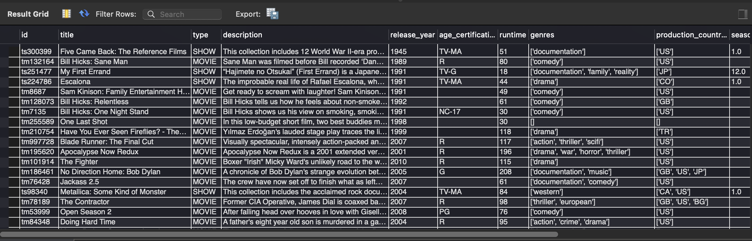

1. Retrieve the first 10 rows from the dataset.

select *

From titles

limit 10;

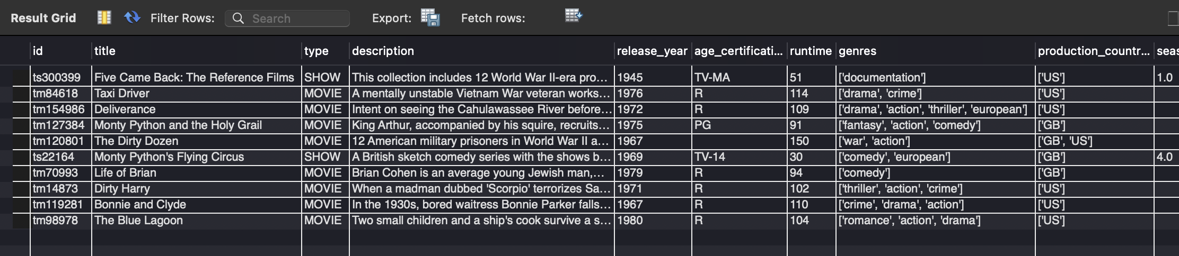

1. Find all unique types (movies or TV shows) in the dataset. Use distinct instead of group by.

select type

From titles

group by type;

1. Get all shows and movies released in a specific year (e.g., 2020).

SELECT * FROM titles WHERE release_year= 2020;

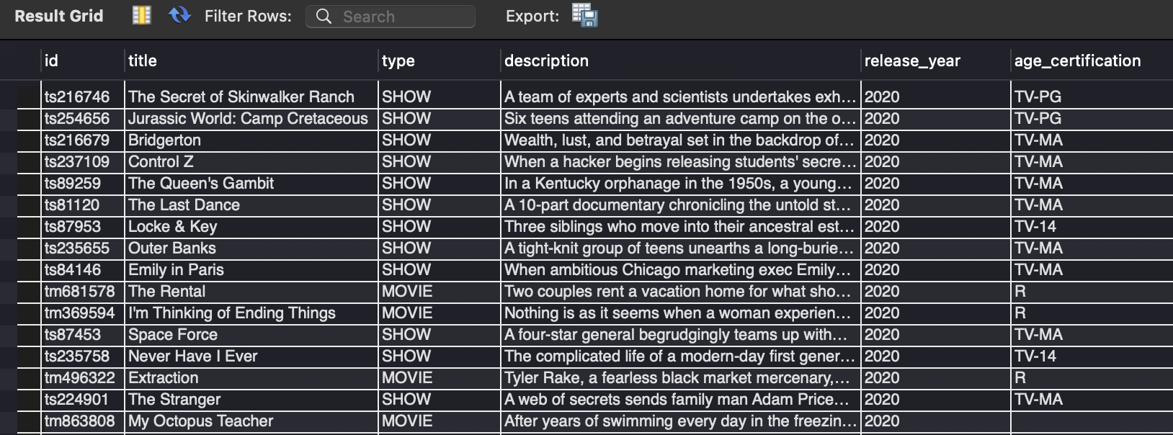

1. Find all titles with a specific age certification (e.g., PG-13).

SELECT * FROM titles WHERE age_certification= 'PG-13';

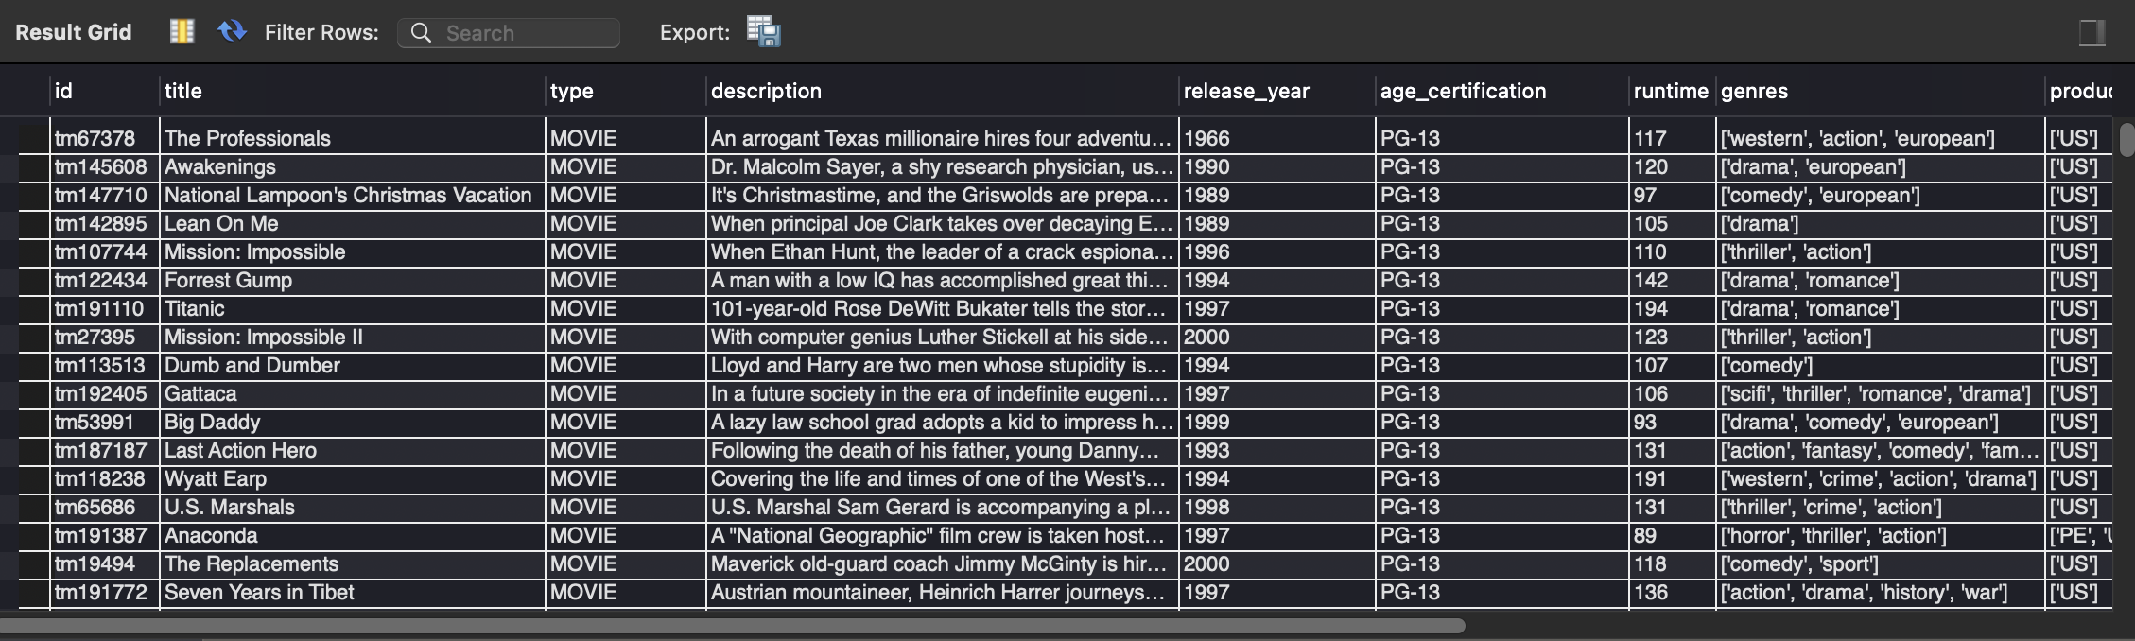

1. Get the count of movies and TV shows separately.

SELECT type, Count(type) As Number_of

from titles

group by type;



**Intermediate SQL Queries**

1. Find the top 10 highest-rated movies based on IMDb score.

select title, imdb_score

from titles

order by imdb_score desc

limit 10;

1. Find the average IMDb score for each genre. Round each average to two decimal places.

select genres, avg(imdb_score)

from titles

group by genres;

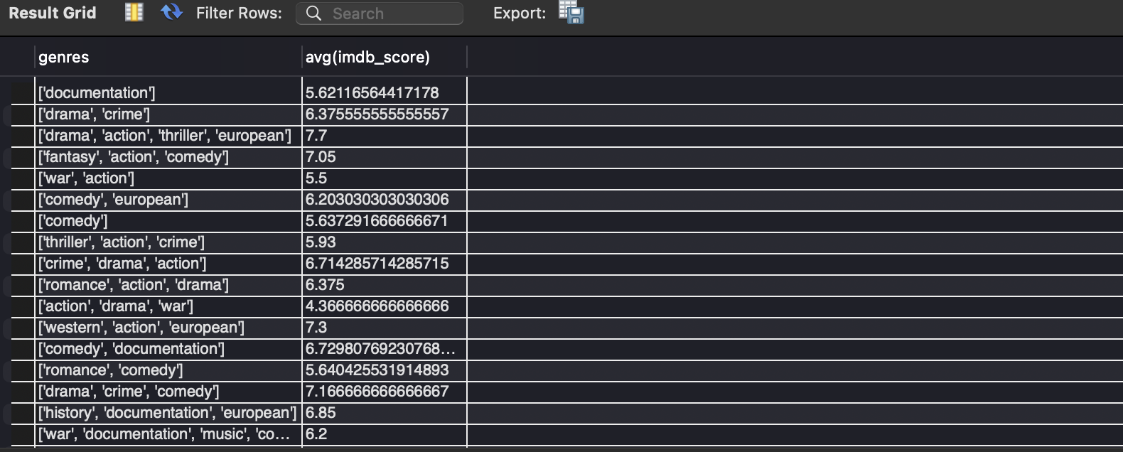

1. Get the total number of titles per production country..count(titles)..group by (prodcution country)

select title, production_countries

From titles;

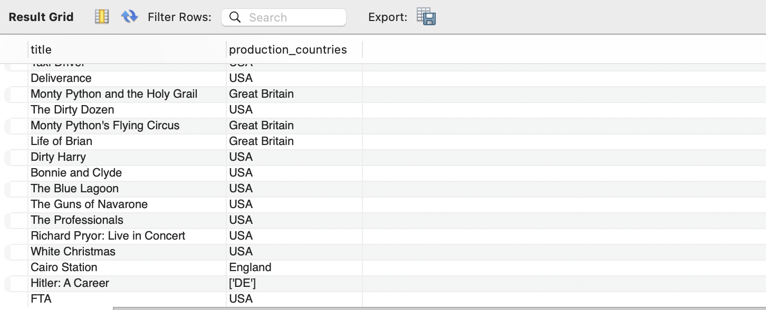

1. Find the most popular movies based on TMDB popularity score.

select title, tmdb_popularity,

RANK() over(order by tmdb_popularity desc) As RANK_top

From titles;

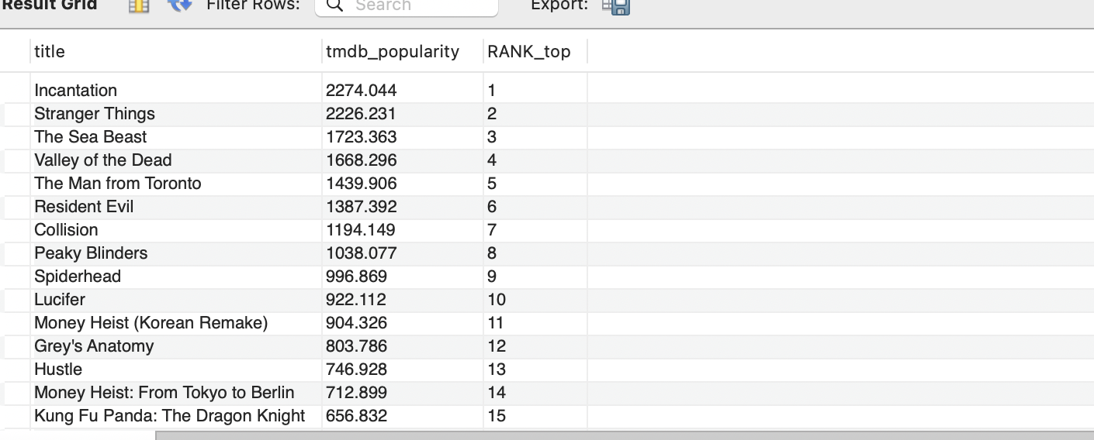

1. Get the longest movies (by runtime) in the dataset.

select title, runtime,

RANK() over(order by runtime desc) Longest_Moive

From titles;

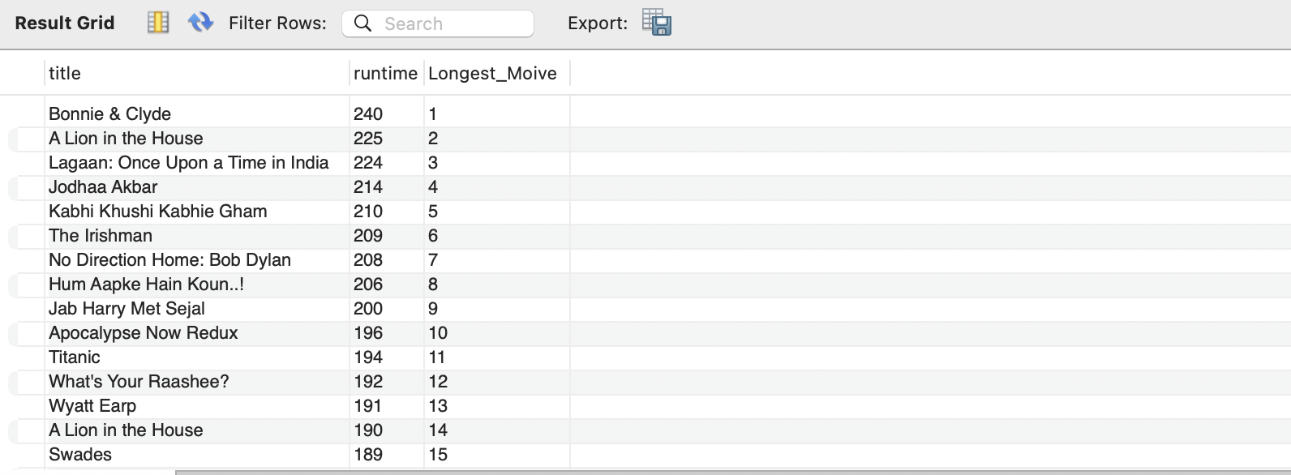

1. Find all movies that have multiple genres (i.e., contain a comma in the genres column).

select type, genres, count(*) As Count

from titles

where type="MOVIE"

group by genres;

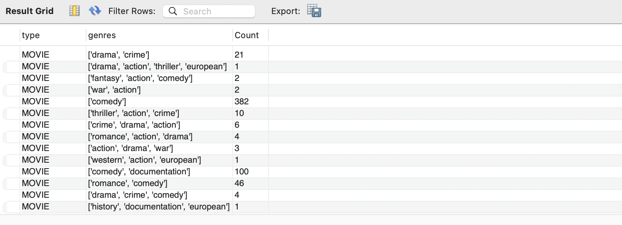

1. Find the top 5 most common age certifications.

Select age_certification, count(*) AS Rep

from titles

group by age_certification

order by Rep desc

limit 5;

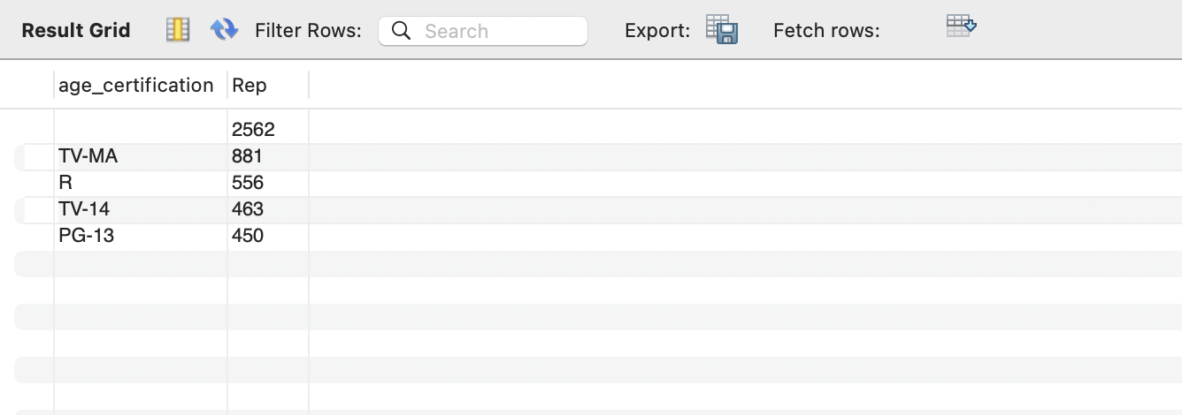

**Joins and Relationships**

1. Retrieve all actors and their associated titles.

SELECT credits. id, credits.name, titles.title

FROM titles

JOIN credits ON credits. id = titles. id;

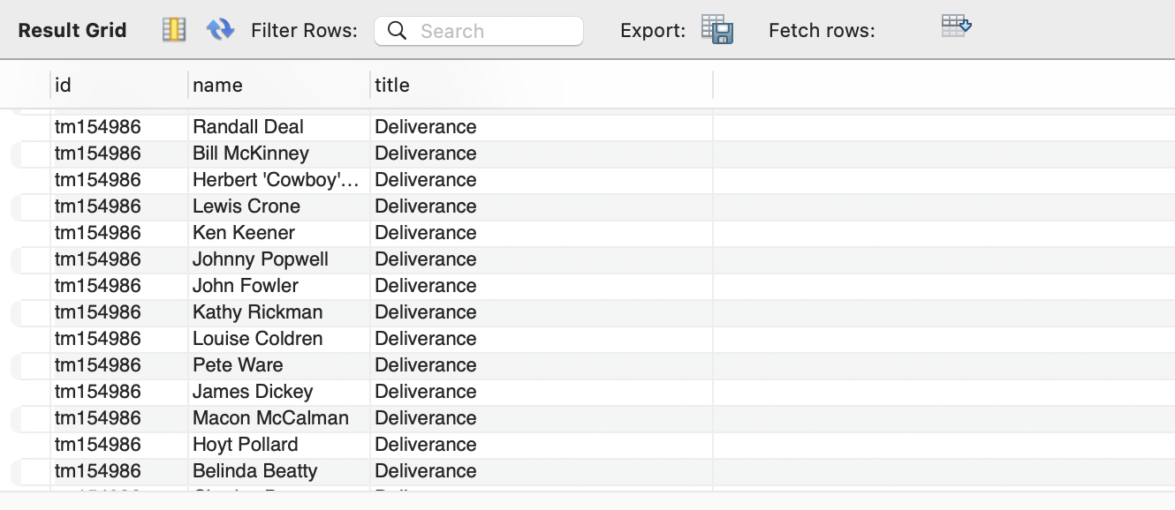

1. Find the top 10 actors who have played in the most movies or shows.

SELECT credits.name, COUNT(titles.id) AS Title_count

FROM credits

JOIN titles ON credits.id = titles.id

GROUP BY credits.name

ORDER BY title_count DESC

LIMIT 10;

Or

Select credits.name, Title_count

From (select credit.name, count(titles.title) AS Title_count

Join titles ON Cridits.id =titles.id

Group by credits.name) As Subquery

Order by Title_count DESC

LIMIT 10;



1. Find the most frequent directors in the dataset.

select name, count(*), role

From credits

where role= 'DIRECTOR'

Group by name;



1. List all shows where a particular actor (e.g., "Leonardo DiCaprio") has played a role.

SELECT credits.name, titles.title, type

FROM titles

JOIN credits ON credits.id = titles.id

where role='Leonardo DiCaprio'& type= 'SHOW';

1. Find the highest-rated movies and their directors.

SELECT credits.name, titles.title, imdb_score

FROM titles

JOIN credits ON credits.id = titles.id

where role ='DIRECTOR' or type='MOVIE'

order by imdb_score DESC;

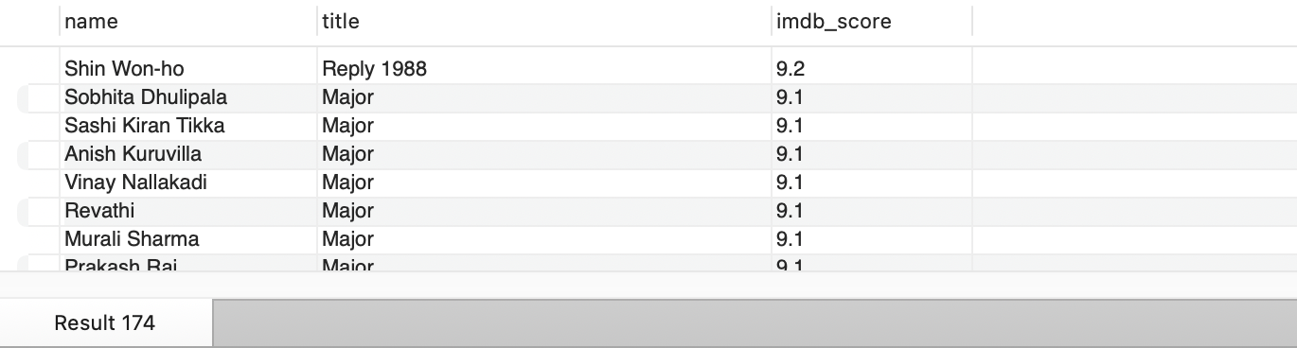

**Advanced SQL Queries**

1. Find the most common pairs of actors that appear together in movies.

-- not underdaning

SELECT c1.name AS actor_1, c2.name AS actor_2, COUNT(*) AS movie_count

FROM credits c1

JOIN credits c2 ON c1.id = c2.id

AND c1.name < c2.name

GROUP BY c1.name, c2.name

ORDER BY movie_count DESC;

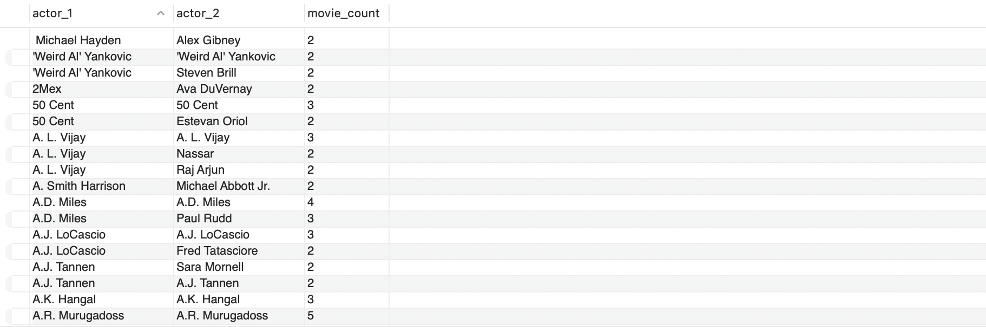

1. Find the most successful production countries based on average IMDb score.

select production_countries, imdb_score

From titles

order by imdb_score DESC;

1. Find actors who have worked in both TV shows and movies.
2. Find the most successful TV shows based on IMDb score.

**Bonus Challenges**

1. Find the percentage of movies vs TV shows in the dataset.
2. Find the year with the highest average IMDb score.
3. Find actors who have appeared in at least 3 movies with an IMDb score greater than 8.0.